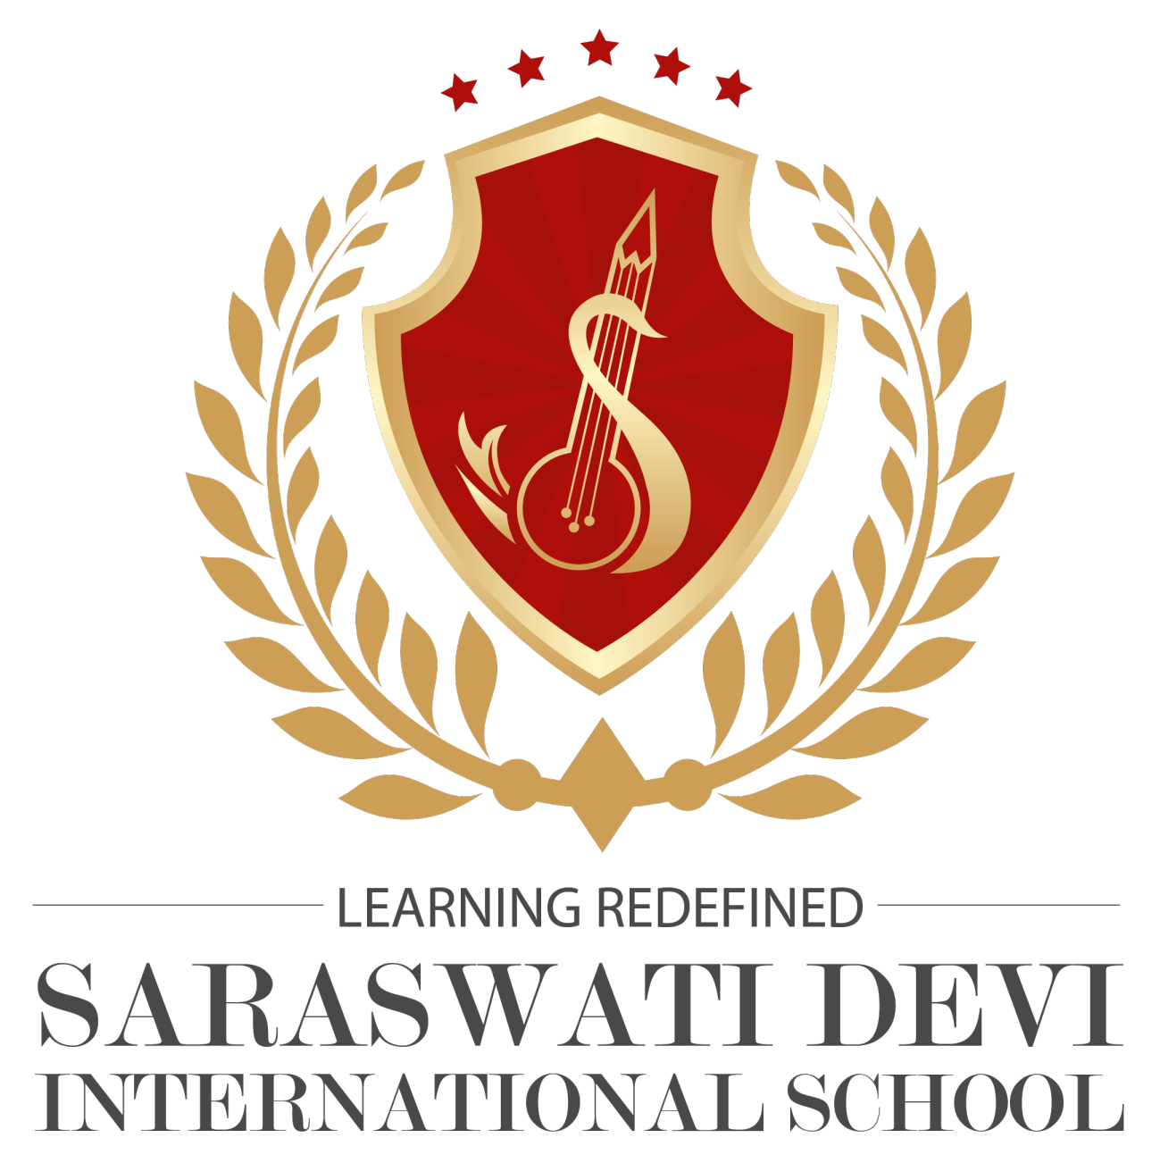
SARASWATI DEVI INTERNATIONAL SCHOOL
Puabagan :: Damodarpur :: Bankura :: PIN-722146 (W.B.)
CLASS -SEC: Pre-nursery |  | SUB: English,Rhymes | DATE: 01/05/2021 |  | Teacher's Name: Aditi Haldar Maji
SL.NO. | NAME |  |  | M.O. |  | FM.
1. | Aitijhya Chand |  |  | 20 |  | 20
2. | Anik Das |  |  | 20 |  | 20
3. | Dipsikha Dan |  |  | 20 |  | 20
4. | Sankalpa Mandal |  |  | 20 |  | 20
5. | MD.mehbub subhan |  |  | 0 |  | 20

